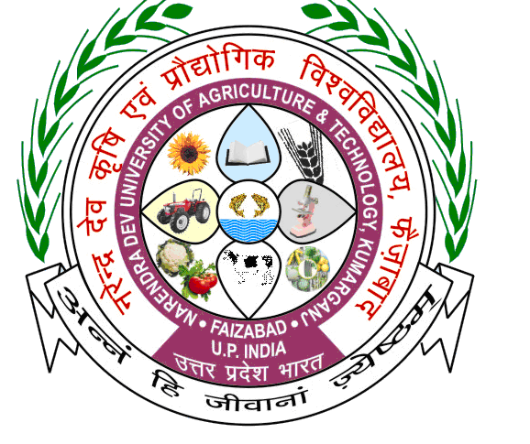 | Acharya Narendra Deva University of Agriculture & Technology,  Kumarganj, Ayodhya (U.P.)-224 229
Please affix latest passport size self-attested photograph

(To be filled by the candidate)

Application Form for the post of
Assistant Professor
(Mark appropriately)
Name of the Applicant
Name of Post Applied for
Father’s Name
Mother’s Name
Mobile/Telephone No.
Email ID
Advertisement No. | Date of Advt. |  |  | Serial No. of post | Last date for submission of application form
Name of Issuing Bank |  |  | DD No. |  |  | Date | Amount (Rs)

Signature of the Applicant

Acharya Narendra Deva University of Agriculture & Technology,
Kumarganj, Ayodhya (U.P.)-224 229

Please affix your latest passport size self-attested photograph

1 | Name  (In Capital Letters) | First Name |  |  |  | Middle Name |  | Surname
2 | Date of birth | Day |  | Month | Year | Age as on last date of advertisement |  | Years | Months
3 | Place of birth | City/Village |  |  |  | State |  | Country
4 | Mother's Name
5 | Father's Name
6 | Address | Correspondence |  |  |  |  | Permanent
 |  | Phone/Mobile:  Email: |  |  |  |  | Phone/Mobile:  Email:
7 | Nationality
8 | Sex | Male/ Female/Transgender: ____________________________________
9 | Community/ Category  (Please strike out whichever options are not applicable) |  | UR/OBC/SC/ST/EWS: _____________________________  Proof enclosed (if belongs to Reserved Category) Sl. No of page:______________
10 | Marital status |  | Married/Unmarried/Divorced: __________________________________  If married, name of spouse ________________________________________

11. Educational Qualifications (Attach additional pages, if required)

ESSENTIAL QUALIFICATION | Name of the Board/ University | Year passed | Subject | Division/ CGPA  (if grading is applicable) | % of Marks (pl. indicates equivalent to CGPA also) | S. No. of proof of enclosure | Weightage given | For office use
 | (a) | (b) | (c) | (d) | (e) | (f) | (g) | (h)
Matriculation
(10th Class)
Higher Secondary (12th Class)
Graduation / Bachelor's Degree
Post Graduation/ Master's Degree
Ph.D.
NET / NET with JRF (for Higher Studies)
Registration with (VCI/SVC)
For A.P. veterinary

12. Research Publication (Publication in peer reviewed or UGC listed journals)

Authors, Year of publication, Title of the paper | Journal Name, Volume and Page No. | Sl. No. of proof of enclosure | For office use

13. Teaching /Post Doctoral Experience.
Particulars | Name of Institution | Nature of work | Value generated | Sl. No. Proof. enclosed | Office use
Teaching Experience
Post Doctoral Experience

14. Award obtained/Training undergone
Particulars | Name of Award/Training | Agency/Institution | Year | Sl. No. of proof enclosed | Office use
International
National
State level

15. List of Certificates and other documents needs to be attached with application form as given below
Sl. No. | Documents to be attached
1 | List of publication
2 | Score card as per detailed given in Table 3A
3 | Reservation certificate (if applicable)
4 | Testimonials, transcripts, certificates, degrees
5 | Experience certificates along with detail of salary per month, grade etc
6 | Other supporting documents
16. Score card: Score card has to be prepared as detailed given in Table 3A for the post of Assistant Professor
17. Have you ever been punished during your studies at College/University?: (Yes/No)
18. Have you ever been punished during your service or convicted by a court of law?: (Yes/No)
19. Were you declared medically unfit or asked to submit your resignation or dismissed?: (Yes/No)
20. Do you have any case pending against you in any court of law?: (Yes/No)
21. Indicate if you possess essential qualification. If yes, give full details. (Yes/No)
22. Indicate if you are physically fit or physically handicapped. Accordingly provide medical fitness certificate or provide certificate of physically handicapped issued by competent authority. (Yes/No)

Declaration by Applicant
I, _______________________________________________ son/daughter of _____________________________________________ hereby declare that all the statements and entries made in this application are true, complete and correct to the best of my knowledge and belief. In the event of any information found false or incorrect or ineligibility being detected before or after the Selection Committee and Board of Management meetings, my candidature/appointment may be cancelled by the University.
I have never been convicted or contemplated for any unlawful activity.
Name (in Block Letter)
_________________________________

Signature of the Applicant

Date: ______________________

*Application not signed by the candidate is liable to be rejected

Annexure

Criteria for Short-listing of Candidates for Interview for the Post of Assistant Professor in Universities. As per Table: “3A” of UGC regulation 2018

Advertisement No…………………………………. Subject: ………………………………….….
Candidate Name: ……………………… Category: GEN/OBC/SC/ST/EWS………………
Father’s Name: ………………………… State you belongs to ……………………….

Phase-I Criteria for Short-listing of Candidates for Interview
Sl.No. | Academic Record | Score
 | Graduation | 80% & Above =15 | 60% to less than 80%=13 | 55% to less than 60% =10 | 45% to less than 55%=05
 | Post Graduation | 80% & Above =25 | 60% to less than 80%=23 | 55% (50% in SC/ST/OBC (non creamy layer)/PWD)to less than 60% =20
 | M.Phil. | 60% & above =07 | 55% to less than 60% =05
 | Ph.D. |  |  | 30
 | NET with JRF |  |  | 07
 | NET |  |  | 05
 | SLET/SET |  |  | 03
 | Research Publication  (2 marks for each research publication published in Peer-Reviewed or UGC-listed Journals) |  |  | 10
 | * Teaching /Post Doctoral Experience  (2 marks for one year each) |  |  | 10
 | Awards
 | International/National Level  (Awards given by International Organisations/Government of India/Government of India recognised National Level Bodies) |  |  | 03
 | State-Level (Awards given by State Government) |  |  | 02
- 9 | Written Test for Assessment of domain Knowledge |  |  | 40
Phase-II Criteria for selection of Candidates after scrutiny
 | Presentation |  |  | 20
 | Interview |  |  | 10
*However if the period of teaching/Post-doctoral experience is less than one year then the marks shall be reduced proportionately.
(A) (i) M.Phil+Ph.D Maximum -30 Marks
(ii) JRF/NET/SET Maximum -07 Marks
(iii) In awards category Maximum -03 Marks
(B) Number of candidates to be called for interview shall be decided by the concerned universities.
(C) Academic Score - 80
Research Publication - 10
Teaching Experience - 10
Total - 100
Written Test for Assessment of domain Knowledge 40
G. Total - 140
NOTE:
- Screening of candidates shall be based on Marks/Score obtained in phase-I only 140(100+40) as per table- ‘3A' of UGC regulation 2018 and as per letter no: E-4229/GS dated 02 July 2021 from Governor Secretariat of Uttar Pradesh.

- Final selection shall be based solely on the basis of candidate’s performances in phase-II that is 30(20+10) as per letter no: E-4229/GS dated 02 July 2021 from Governor Secretariat of Uttar Pradesh.

Date: Signature of Candidate

Members of Screening Committee

